**Steganography with CUDA using Google Colab**

Juan David Torres Velasco A01702686

**Abstract** - **The following document show the implementation of Steganography in images using CUDA C and OpenCV with Google Colab as the running environment.**

***I. Introduction***

Hiding information has been always necessary for humankind and the beginning of the digital era brought a lot of ways to hide information. Steganography is one of the many ways to encode, encrypt or hide information, this is done by hiding the information in the data.

The project’s objective was to implement steganography in images using CUDA C and OpenCV, given that I don’t have a computer with an NVIDIA GPU to run CUDA I had to use Google Colab to implement my solution. But because there are no solutions on the internet on how to use OpenCV with Google Colab I had to find a solution and the following includes a manual that explains step by step how to use OpenCV with Colab.

***II. Steganography***

Steganography is a way to hide data into data meaning that you can hide files inside of other files. There are many ways to implement steganography, data can be hidden on images, audio and any other representation of data imagined. It is important that the file where the data is being hidden doesn’t change, therefore in images a good technique to use to hide data is the LSB or least significant bit which changes on each pixel the least significative bit on every color.

The LSB technique hides each bit of the data that wants to be hidden in one color of each pixel and this was the technique I used for my implementation. Given that CUDA can do many operations at once with the use of threads and the GPU, then the idea is to use each thread to hide only one bit from the message taken from a text file. Because each bit is independent from each other steganography is a great way to apply the CUDA programming language and separate even the colors of each pixel to change their least significant bit.

***II.I Hiding***

To do the process of hiding I received the name of the files that were going to be used as arguments in the terminal the name of the image file where the message wants to be hidden, the text file with the message that wants to be hidden and finally the name of the output image that is going to contain the message hidden. Once I have the files, I read first the text file and obtain the message, obtain the image file with OpenCV and check whether the message fits into the image or not you have to check if (widthImage * heightImage * 3) > ( (textSize + 1) * 8).

After doing so the next step was to do a cudaMalloc to allocate memory on the device and copy the image to it with cudaMemcpy to access the image from the gobal function and change the pixels from the image. Then to do the global function it is important to create the 3d Blocks and Threads with dim3, for the case of Blocks use ((image.cols+ ThreadsPerBlock-1)/ThreadsPerBlock) and for the second attribute instead of using columns use image.rows, and for the Threads use for both attributes ThreadsPerBlock. Then the call to the global function is done and we use the previously created Blocks and Threads and pass as paremeters to the global function the d_image, the d_text which is the message to use in the device and the textSize which is going to be de actual size of the process of hiding.

The global function will change the least significant bit of every pixel RGB component, to do so the offset is calculated as col + row * blockDim.x * gridDim.x where col = blockIdx.x * blockDim.x + threadIdx.x and the row = blockIdx.y * blockDim.y + threadIdx.y. The index to use for the text then is calculated as index = offset/8.

After this is done the bit_count = 7 – (offset%8) which is how much the text[index] will be shifted to the right so the actual least significant bit on the already shifted bits will be the change on the pixel color.

The change of the LSB is done through an if charBit &1 where charBit is the already shifted bits and if the following if is 1 the image[offset] |= 1which will change the LSB to 1 but if the conditional is false then the LSB is change to 0 doing the following image[offset] &= ~1.

Once the bits are changed the device image is copied to the output image that is on the host, finally I added eight more bits to the message so the program that show the hidden message knows when to stop and finllay use the imwrite function on OpenCV to write the image intro the system with the name of the file specified when the program is run.

***II.II Showing***

The showing program receives as argument the image file where the hidden message is in, and one the program has the name of the file it uses imread to read the image using OpenCV. The image must be used the same way as the hiding program, the image is copied to the device and create the same Blocks and Threads as the hiding program as well. Then the gobal function must be called and the attributes passed the image, where the text is going to be saved and finally the width*height which is the size of the image.

In the global function the offset is used as well as in the hiding code, the text then will change the text[offset] to 0 by default but if the condition that (image[offset]&1) is 1 this means that the LSB of the corresponding color component is 1 and the text[offset] is changed to 1 using text[offset] |= 1. Once the text is gathered the host will convert each of the numbers contained in the text to a char using a function and if the char is “00000000” then it will stop reading and print the message that was hidden on the image.

***III. Manual to use OpenCV + CUDA in Google Colab***

The objective of this manual is to show how to work with OpenCV in Google Colab given that there can be some hardware issues that can prevent us to do certain development like the use of CUDA in a computer without an NVIDIA GPU.

I will be using some pieces of code from the implementation steganography with CUDA project as way to show how OpenCV can be used.

***1. Installing Google Colab***

Firstly, it is necessary to connect Google Colab to your Google account (if you already have it connected skip to the next step). To do this you will have to click on the **New** button, the same one used to create new folders or documents, then click on **More** and afterwards click on **Connect more apps**.

Figure New button

Figure Connect more apps

Then search for Colaboratory and add it to Google Drive using the drive button in the down right corner

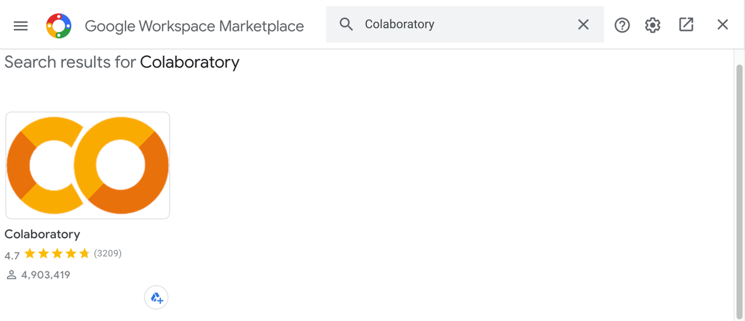

Figure Install Colaboratory

Click install and you will have to accept the permissions in order to install it.

Figure Install Colaboratory

***2. Creating Notebook***

Once Google Colab is installed, is necessary to create a Google Colab notebook through Google Drive, it can be created from any folder, but to have a better organization it will be done on the same folder where the CUDA files are going to be. Open the folder you’re going to be using and click the **New** button and select **Google Colaboratory**. This will create your Colab NotebookGraphical user interface, application

Figure 5 Create new Notebook

***3. Connect the GPU to Google Colab***

To change the runtime, you have to click on edit, then notebook settings as it is shown in the figure 6

Figure Notebook settings

Once in the notebook settings you will have to change the hardware accelerator to GPU and save the settings as it is shown in the figure 7.

Figure Hardware accelerator

***4. Connect Drive to Google Colab local environment***

*Disclaimer. You will have to do this every time you reconnect to your Google Colab notebook.*

You will have to add a piece of code to your Google Colab Notebook, to do so you will have to create a code block clicking on **+ Code.** 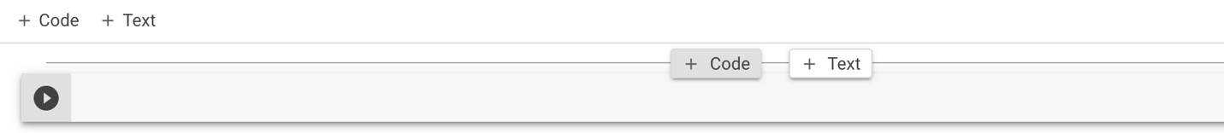

Figure Insert Snippet of Code

Then add the following snippet of code:

from google.colab import drive

drive.mount('/content/drive')

%cd "/content/drive/My Drive/YourFolder"

!pwd

If you added the folder to the root of your Google Drive you will have to replace “YourFolder” with the name of your folder. This folder is going to be the one in where the CUDA files will be present. Make sure that the path to your folder is correct, note that the root Drive Folder is **"/content/drive/My Drive”**.

Figure Authorization code copy

Run the snippet of code and once you run it a prompt like the following will appear. You will have to click on the link that is shown, follow the instruction and copy the authorization code to your clipboard using the clipboard button.

Then you will have to paste the code to the text field shown in the figure 10 and press the enter key.

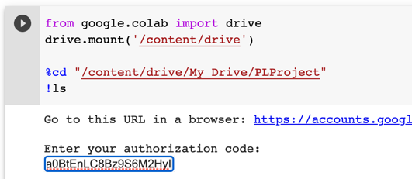

Figure Authorization Code Paste

***5. CUDA File***

Then you will have to create new files in the folder you have the Google Colab notebook. You can create them using the Google Drive “Text Editor” that can be installed as the Google Colab app was installed. You can also upload the files from your computer.

Figure 11 Text Editor App

Figure 12 File CUDA Creation

Once the file is created you will have to add the following snippet of code to the header.

#include <stdio.h>

#include <stdlib.h>

#include <opencv2/core/core.hpp>

#include <opencv2/highgui/highgui.hpp>

#include <opencv2/imgproc/imgproc.hpp>

#include <opencv2/opencv.hpp>

using namespace cv;

Now you can write whatever code you’d like in CUDA C using Open CV, for practicality I will add the following code which reads an image and makes an exact copy of it using CudaMalloc and CudaMemcpy. This code is a small part of my project of steganography, if you want to run it make sure you have an image file called image.png and that is on the same folder as the CUDA file.

*int* main(){

Mat image = imread("image.png");

*int* imageSize = image.step * image.rows;

unsigned char *d_image;

cudaMalloc<unsigned char>(&d_image, imageSize);

cudaMemcpy(d_image, image.ptr(), imageSize, cudaMemcpyHostToDevice);

Mat output(image.rows, image.cols, CV_8UC3);

cudaMemcpy(output.ptr(), d_image, imageSize, cudaMemcpyDeviceToHost);

imwrite("output.png", output);

return 0;

}

***6.1 Running terminal Google Colab Pro***

To run the code if you have Google Colaboratory Pro you can use the terminal button in the below left corner as it shown in the figure 13. 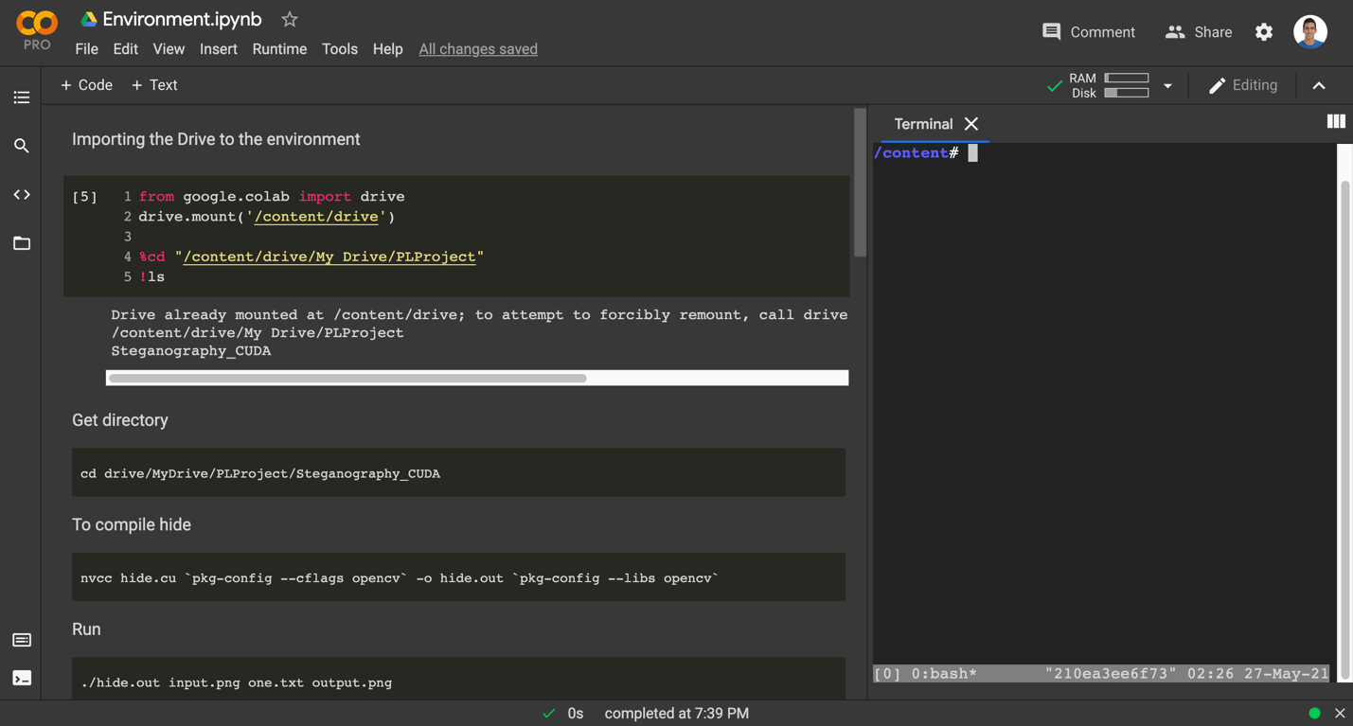

Figure 13 Google Colab Pro Terminal

Then you will have to go to the directory where the files are located inserting the following code in the terminal.

cd drive/MyDrive/MyFolder

***6.2 Running terminal Google Colab free edition***

If you don’t have Google Colab Pro you can add to snippets of code to your notebook that will create a terminal on the interface. It is important that these codes are separated as they work into two pieces of code.

from IPython.display import JSON

from google.colab import output

from subprocess import getoutput

import os

*def* shell(*command*):

if command.startswith('cd'):

path = command.strip().split(maxsplit=1)[1]

os.chdir(path)

return JSON([''])

return JSON([getoutput(command)])

output.register_callback('shell', shell)

#@title Colab Shell

%%html

<div id=term_demo></div>

<script src="https://code.jquery.com/jquery-latest.js"></script>

<script src="https://cdn.jsdelivr.net/npm/jquery.terminal/js/jquery.terminal.min.js"></script>

<link href="https://cdn.jsdelivr.net/npm/jquery.terminal/css/jquery.terminal.min.css" rel="stylesheet"/>

<script>

$('#term_demo').terminal(async function(command) {

if (command !== '') {

try {

let res = await google.colab.kernel.invokeFunction('shell', [command])

let out = res.data['application/json'][0]

this.echo(new String(out))

} catch(e) {

this.error(new String(e));

}

} else {

this.echo('');

}

}, {

greetings: 'Welcome to Colab Shell',

name: 'colab_demo',

height: 250,

prompt: 'colab > '

});

After you run these two lines of code the terminal will appear as the figure 14 shows. The terminal’s current folder is the folder you wrote in the step 4.

Figure 14 Terminal

***7. Compile and Run***

To compile the Cuda file because everything is already preinstalled in Google Colab you will only have to run the following code on which ever terminal you are using. Change file.cu to the name of your file to compile the program.

nvcc file.cu `pkg-config --cflags opencv` -o file.out `p-config --libs opencv`

Once it is compiled to run the program you will have to run the following code on the terminal. The name of the file changes depending on the file.out line on the code above.

./file.out

***IV. Conclusion***

The use of steganography in images can be used by many people as a way to pass secret messages from devices, right now that many of us are afraid that Google or Facebook are spying on us and using our information for their benefit the security and privacy has become a very valuable asset.

The use of CUDA for steganography can optimize a lot of the time that the message is being hidden in the image and can be a great way to hide big data files into much bigger files.

But right because not everybody has access to an NVIDIA GPU a great way to do this implementation is with Google Colab and with this manual will help more people be able to do images processing and implementations using CUDA and OpenCV because there is no information on the internet on how to do it. I’m satisfied that this will help a lot of people in the course and around the world that wants to implement CUDA without the constraint of needing a NVIDIA GPU.

***V. References***

Kessler, G. (2002, septiembre). *Steganography*. GaryKessler. <https://www.garykessler.net/library/steganography.html>

Choudary, A. (2020, 25 noviembre). *Steganography Tutorial – A Complete Guide For Beginners*. Edureka. <https://www.edureka.co/blog/steganography-tutorial>

Korakot, A. (2019, 13 diciembre). *How can I run shell (terminal) in Google Colab?* Stack Overflow. <https://stackoverflow.com/questions/59318692/how-can-i-run-shell-terminal-in-google-colab>

Wilson, D. (2014, 28 abril). *Convert a string of binary into an ASCII string (C++)*. Stack Overflow. <https://stackoverflow.com/questions/23344257/convert-a-string-of-binary-into-an-ascii-string-c/23344876>